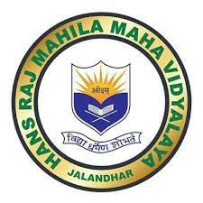

AQAR 2023-24
7.1.6
Claen and Green Campus
Certificates of the Awards Received

CLEAN AND GREEN CAMPUS RECOGNITION/AWARDS

Principal Dr Ajay Sareen honoured as Eco Visionary Principal by National EduTrust of India

Monday, 16 September 2024

Hans Raj Mahila Maha Vidyalaya, the premier institute of North India, in collaboration with National EduTrust of India (registered under Ministry of MSME, Govt. of India) organized ‘Awards Ceremony of 30-Day Environment Challenge’ under the able guidance of Principal Prof. Dr. (Mrs.) Ajay Sareen. The chief guest of the occasion was Dr. Harsimrat Kaur Grewal, Assistant Commissioner, GST Ludhiana and the guest of honour was Mr. Samarth Sharma, CEO, National EduTrust of India. The coordinator of the event was Dr. Anjana Bhatia. The event started with the lighting of lamp and DAV gaan. Principal Dr. Sareen welcomed the guests with green planter and ‘phulkari’. Dr. Harsimrat Kaur delivered a lecture on the crucial topic of women's empowerment, with a special emphasis on financial independence. She eloquently highlighted the importance of women achieving financial autonomy as a key aspect of empowerment. She emphasized that a woman can handle everything with a positive attitude. HMV was honoured with several prestigious certificates in recognition of its commitment to excellence and sustainability. The institution got state level award for outstanding performance and eco-friendly college certificate in 30-day environment challenge. These certificates included the "Eco-Friendly College Certificate" for our dedication to environmental sustainability, a certificate to HMV College for outstanding participation, and the "National EduTrust of India – Eco-visionary Certificate" presented to Principal Dr. Ajay Sareen for her visionary leadership in promoting eco-friendly practices within the college. Dr. Anjana Bhatia was greeted with green guide certificate. Among students, Sushila Gupta of B.Sc. stood 1st in Instagram video making competition with the maximum likes. Students of B.Com Sem-5 (Sakshi Vaid, Dilpreet Kaur, Nandini Dhiman, Harshdeep Kaur) were honored with certificates for standing 2nd in state level Instagram reel making competition related to sustainable environment. The stage was conducted by Dr. Anjana Bhatia. The event event ended with the recitation of National Anthem.

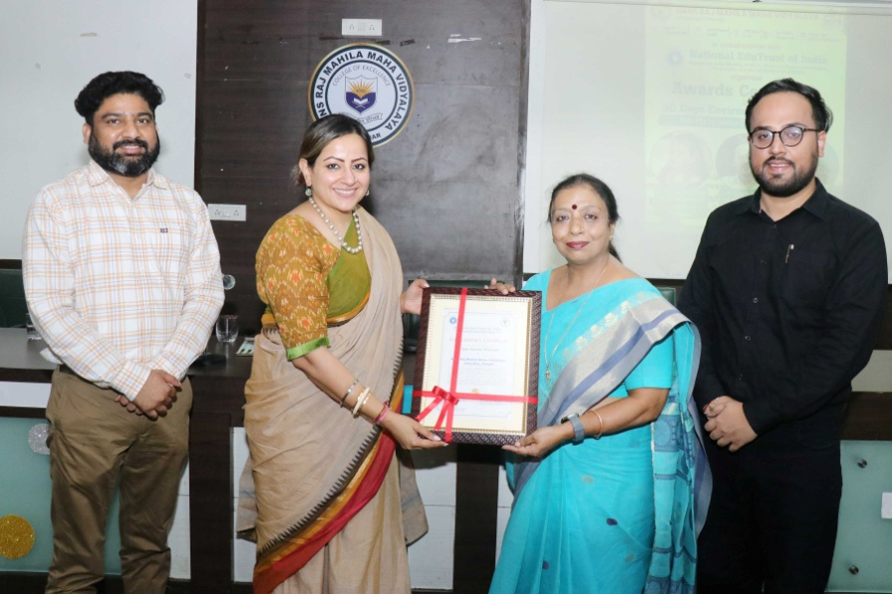

http://hmvnews.blogspot.com/2024/09/principal-dr-ajay-sareen-honoured-as.html

